Media Advisory
Wednesday, January 13, 2021
Contact: Sam Schwartzkopf
Office: (804) 646-6936
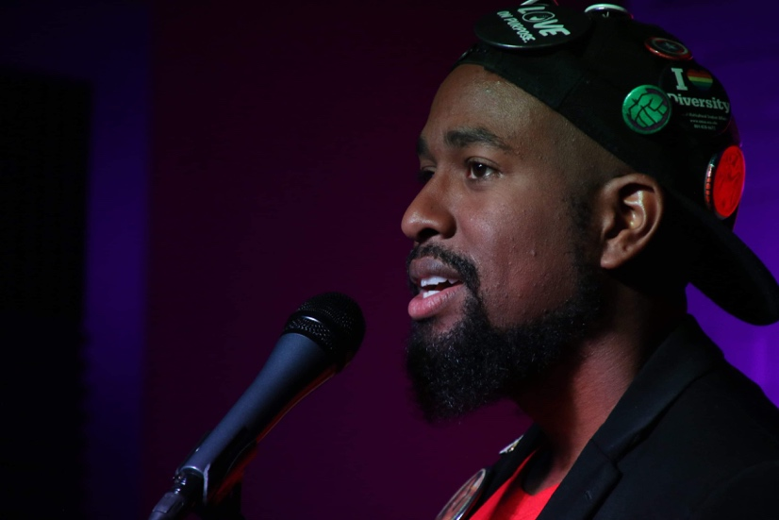
Cell: (804) 418-2056
Sam.Schwartzkopf@richmondgov.com
City names Roscoe Burnems first Richmond Poet Laureate
Richmond, VA — The City of Richmond has selected its first poet laureate, Douglas Powell, known in the community by his stage name, Roscoe Burnems. Burnems is a poet, published author, spoken-word artist, comedian and teacher.

Burnems has donated his time to the St. Joseph’s Villa Alternative Education Program, University of Richmond’s Partners in the Arts and ART 180, in addition to regularly leading poetry workshops at multiple middle and high schools in the City of Richmond. He is a National Poetry Slam Champion, a former TEDx speaker and the founder of the Writer’s Den Art Collective.

“It is the diversity of the city and the adversities that we are able to overcome as a community that cultivate our resilience as people,” said Burnems. “This is the soil for change and progression to sprout and expand into a tree that blooms the fruit of our tenacity. We decide if that fruit is sweetened with peace or embittered with division.”

Evidence of an interest in and capacity for community engagement was part of the poet laureate selection criteria and a top priority of the mayor’s.

“The Richmond Poet Laureate should relish showing kids, teens and adults the healing, restorative power of the written word,” said Mayor Stoney. “Roscoe has exhibited time and again his interest in bringing poetry to the people, and his list of ideas for engagement projects tells me he’s the Richmonder for the job.”

The first ever Richmond Poet Laureate has proposed interweaving poetry into public visual art projects, hosting spoken-word competitions and showcases for youth, and partnering with Richmond Public Library system to organize a series of accessible workshops.

Said Burnems of his new post: “I can’t wait to get started.”

The Richmond Poet Laureate will make his public debut at the Poe Museum’s Birthday Bash, a virtual celebration of Edgar Allan Poe’s 212th birthday. Deputy Chief Administrative Officer for Human Services Reggie Gordon and Burnems will discuss the role of the poet laureate, how Richmond shaped his poetry and upcoming ways the laureate will engage with the community. Click here to learn more about the free festivities.

To learn more about Roscoe Burnems, click here.

To learn more about the Richmond Poet Laureate program, click here.
##

