Media Advisory
Wednesday, September 16, 2020
Contact: Sam Schwartzkopf
Office: (804) 646-4642
Sam.Schwartzkopf@richmondgov.com
City, partners launch Richmond Poet Laureate program
Application for poet laureate position open now
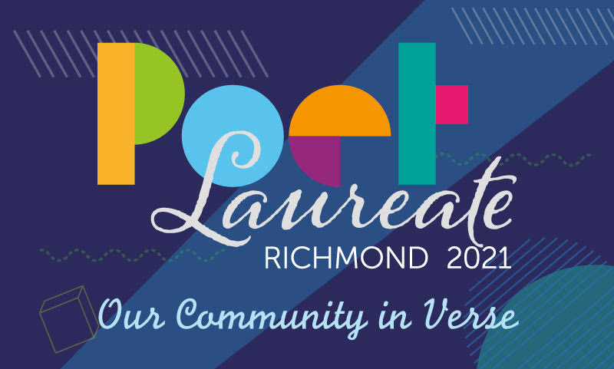

Richmond, VA — The City of Richmond has launched the Richmond Poet Laureate Program to highlight gifted artists in Richmond and use the literary arts to provide support in an unprecedentedly challenging time.

With the freedom to develop their own projects during their term, the Poet Laureate’s main task will be to promote poetry. This will include interfacing with residents already interested in poetry and serving as a literary arts liaison to communities less familiar with the medium.

The Richmond Poet Laureate will serve as a literary leader and voice for the city for a two-year term. The first term will last from January 2021 to December 2023.

Applicants must have been a resident of Richmond or surrounding counties for the last five years and be at least 21 years of age. Lack of traditional publication credentials should not dissuade interested applicants. During the selection process, weight will be given to the applicant’s commitment to the Richmond community and dedication to the craft of poetry. Interested parties can apply here.

Applications to serve as Richmond Poet Laureate will close November 5 at 5 p.m.

The idea began in the Human Services portfolio, where employees noticed an increasing number of Richmond residents seeking support. The challenges of the pandemic presented an opportunity to simultaneously support artists and lift spirits.

“Richmond should always embrace the arts as an accessible way to provide hope and encouragement,” said Human Service DCAO Reggie Gordon. “The Poet Laureate will give us another opportunity to use the power of words to heal wounds, open hearts and minds and weave us closer together.”

The Poet Laureate Committee includes representatives from numerous community organizations dedicated to uplifting the literary arts. Generous donors have agreed to provide an annual $4,000 honorarium to the chosen candidate to support their work and compensate for their time.

Members
Stefanie Fedor, VisArts
Paula Gillison, Poet/The Writers Den RVA
Georgie Green, Poet Laureate Program
Valley Haggard, Life in 10 Minutes Writing Studios
Brian Henry, UR/Poet
Katharine Herndon, James River Writers
Jean Huets, Circling Rivers, a local press
Catherine Ingrassia, Department Chair, English, VCU
Kelly Justice, The Fountain Bookstore
Joanna S. Lee, Poetry Society of Virginia, River City Poets
Deanna Lorianni, Zuula
Patty Parks, Richmond City Office of Human Services
Chris Peterson, Richmond Public Library Board
Casey Polczynski, Virginia Commission for the Arts
Robert Pruett, Brandylane Publishers
Ward Tefft, Chop Suey Bookstore
Aaron-Paula Thompson, The Poe Museum
Sandra Treadway, Librarian of Virginia
Dianne Wilmore, Richmond Public Library Manager of North Avenue Library
Those interested in applying to serve as the Richmond Poet Laureate can apply here.

##

